Hydraulics & Pneumatics LAB6

Roll No :2022-MC-58

Task: Use and gate in any application that compromises an actuator, sensor, valves, logical valves with indirect control

Requirements(parts);

1. Pneumatic supply
2. Pressure Regulator
3. Pressure Guage
4. Multiple output single input expansion board
5. Push buttons (3/2 way)
6. And valve
7. Double acting cylinder
8. 5/2 way pneumatically operated valve
9. Roller valve
10. Connecting pipes

Description;

Scenario is, that we will use the and gate to operate double acting cylinder not directly but with help of pneumatically operated 5/2 Way valve so as to avoid the air locking and two push buttons will be used one for moving cylinder to B position and the 2nd valve to lock the old position, when the 2nd valve is pressed it retains position B while in unpressed condition Retains position A

Circuit diagram;

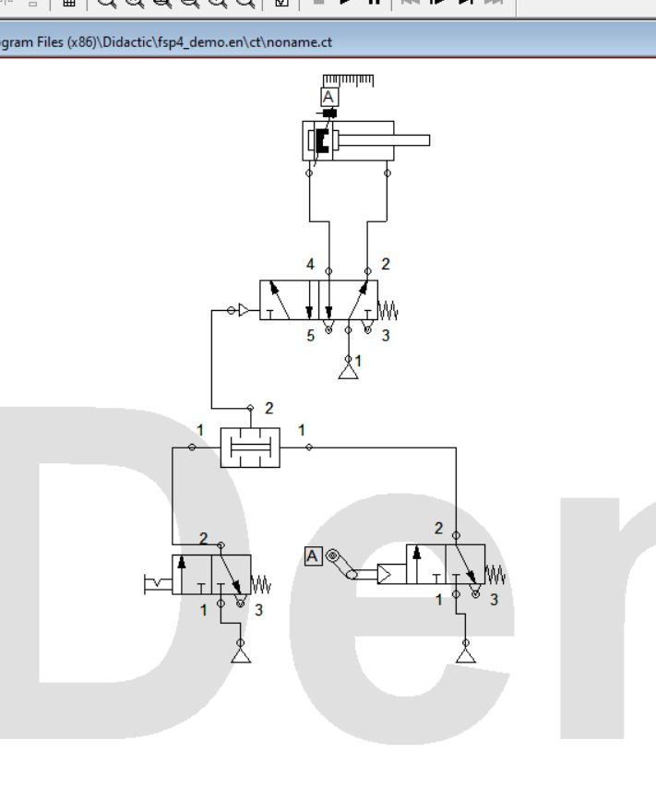

Physical Configuration;

